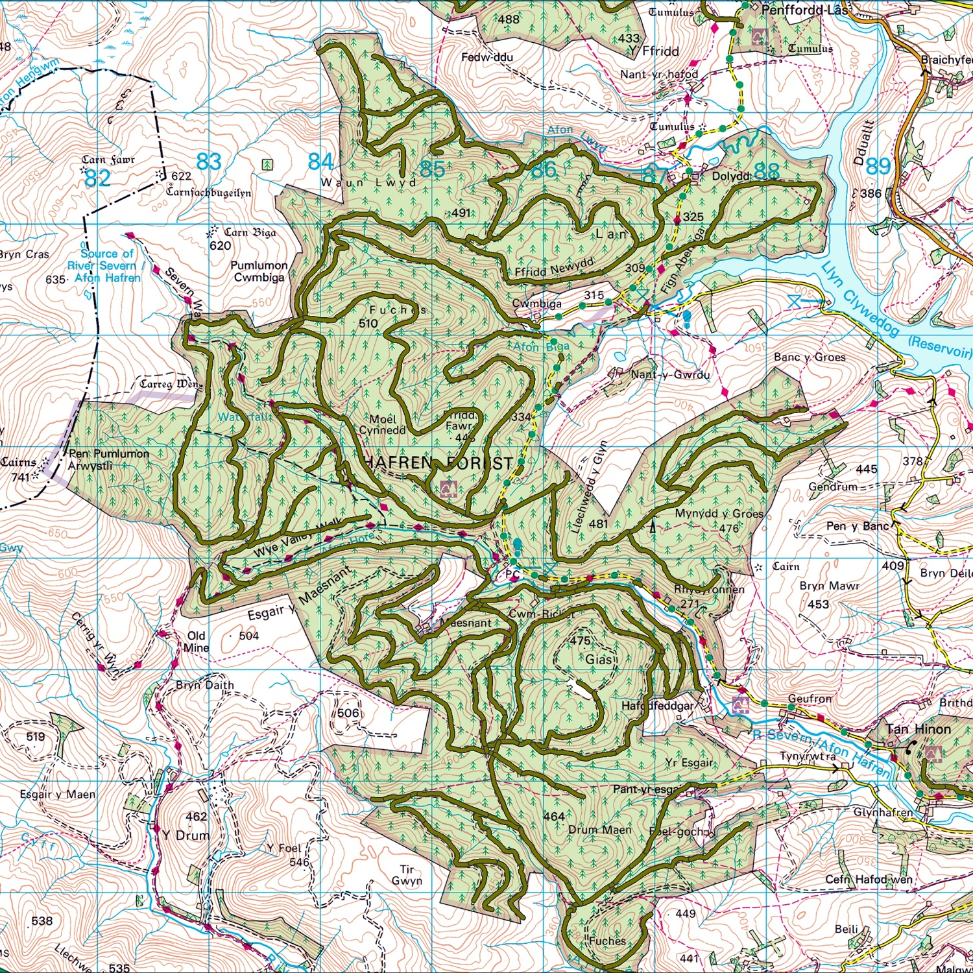

Contents Page

Section A: Developer Information 2

Section B: About your proposed Development 2

Section C: Developer Signature 3

BEFORE SUBMITTING THIS FORM PLEASE ENSURE YOU HAVE:

- Spoken to the Energy Delivery Programme team;
- You must complete all sections or your proposal will be rejected;
- For enquiries please contact your Project Manager or the following email address:

energydeliveryprogramme@cyfoethnaturiolcymru.gov.uk

Section A: Developer Information

A.1: Main Contact Details. This should be the Developer making the application.
Your title (Mr, Mrs, Ms, Miss, Other)
Your name
Developer Name (if you’re a company - as it appears on your governing document)
Address (registered address if you’re a company) |  | Postcode
Telephone |  | Mobile
Email
Website

Section B: About your proposed Development

B.1. PROPOSED DEVELOPMENT
a. LOCATION - attach a map (scale 1:10,000) outlining the boundary / route of your scheme and use of the NRW Managed Estate, illustrating the centre point of the proposed Development area annotated with a National Grid Reference (6 figure).

b. DEVELOPMENT OUTLINE - describe the proposed Development in brief (e.g. access to a wind farm or solar farm, cable run route etc).

c. DEVELOPMENT TIMELINE – please provide your current timeline for the proposed development. We understand that this may only be indicative at this stage.

Section C: Developer Signature

We declare the information in this application to be true to the best of our knowledge at the time of submission.

Name (please print)
Position in organisation
Date
Signature

Please submit the completed Application Form to the Energy Delivery Programme office at the following email address or postal address and copy to the Project Manager as appropriate:

energydeliveryprogramme@cyfoethnaturiolcymru.gov.uk

Programme Office Manager
Energy Delivery Programme
Natural Resources Wales
Welsh Government Building
Rhodfa Padarn
Llanbadarn Fawr
Aberystwyth, Ceredigion
SY23 3UR

v. February 2016

