This note is collated by NRW from submissions from NRW staff and Forum members prior to National Access Forum Meetings in order to facilitate the sharing of information under item 10. Please note that items are included as provided by their author.

Welsh Government: John Watkins

There is no update on the timetable for a green paper on access to the outdoors. The commitment to publish a green paper remains, and the Minister for Natural Resources will consider this matter in due course.

The Minister for Natural Resources is currently the Member in Charge for the Wellbeing of Future Generations (Wales) Bill, and the Planning (Wales) Bill. He is also intending to introduce an Environment Bill (working title). The connections between this package of proposed legislation is set out in this note:
http://gov.wales/docs/desh/publications/150223-three-bills-diagram-en.pdf

The Environment Bill is yet to be introduced – and it is protocol for officials not to give out dates of when it may be introduced as this is a matter for the Assembly’s Business Committee. You will find the latest on the progress of the other Bills at:
http://www.assembly.wales/en/bus-home/bus-legislation/bus-legislation-progress-bills/Pages/bus-legislation-progress-bills.aspx#welsh-government

British Horse Society: Mark Weston

Bridleway Sign
Newport City Council has produced a bridleway sign advising cyclists to slow down. See below.
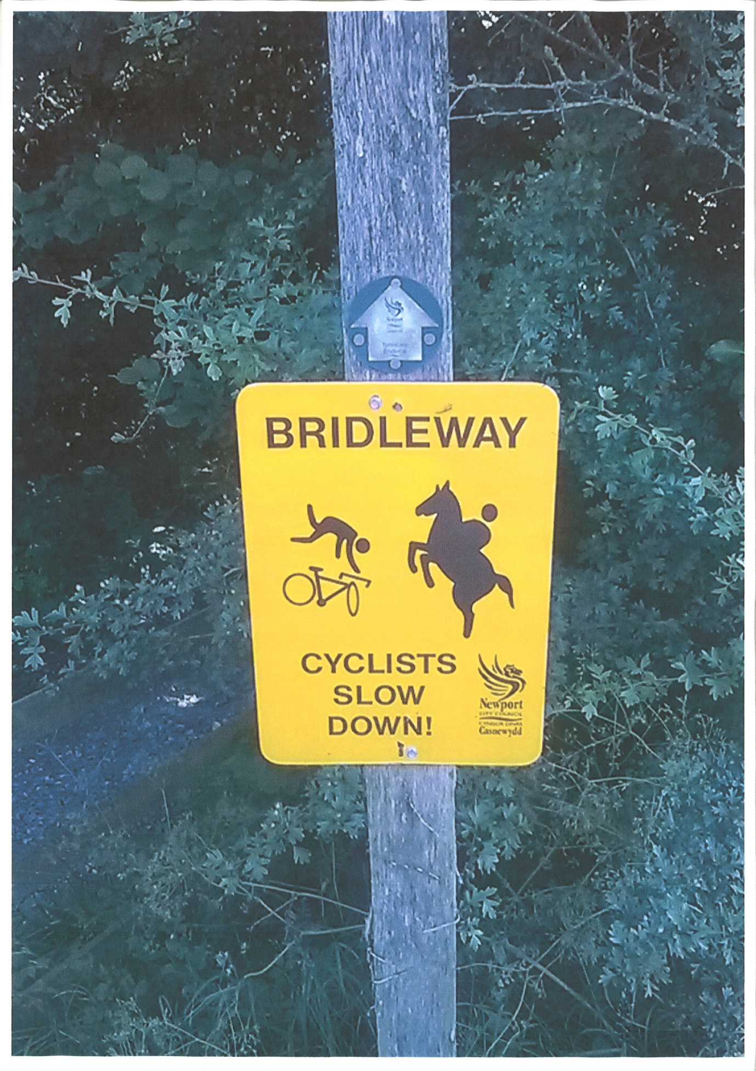

Rhymney Trail
We are working with Sustrans to secure access for horse riders on the trail and any extension of it.

Paths for Communities Fund
The BHS has set up the BHS Paths for Communities Fund, and has earmarked £25,000 for its local committees and Equestrian Access Groups to bid for to help towards securing new equestrian rights of way.

2026
Following the issuing of the Society’s 2026 Toolkit last year the Society has published a new leaflet that guides anyone through how to research a historic equestrian route and submit an application for a definitive map modification order application to have it recorded on the definitive map.

Access Week
The Society’s Access Week 2015 runs between 23 – 31 May to celebrate equestrian access away from motorised traffic and those who do so much to protect and enhance the equestrian public rights of way network.

Crychan Forest
Issues with unauthorised motorised usage. BHS is working with NRW, Police and other parties to try to address the issues.

British Mountaineering Council: Elfyn Jones – BMC Access & Conservation Officer (Wales)

Strategic Plan 2015-19. A new strategic plan has been produced for the organisation for the next four years and the main changes and focus for the next four years are to recognise that the majority of BMC members are not actually rock-climbers but hill-walkers and that there is a need for the organisation to work better to reflect the members interest. The new aims for the next four years for the organisation are:-
- Hill walking –to become the ‘natural home for hill walkers’. (over 61% of members state that hill-walking not climbing is their primary activity)
- Young people – to improve the way we connect with 14-25 year olds.
- Membership – overall 2.75% increase per year.

Winter Climbing Information Project. Working with Natural Resources Wales and Snowdonia National Park it was identified that climbers carrying out winter climbing activities (with ice axes and crampons) in Cwm Idwal National Nature Reserve could potentially be damaging the protected alpine flora found on the cliffs here. The cliffs here contain some of the very best ice climbing in the UK but are also internationally important for the assemblages of arctic-alpine flora. In order to minimise impact climbers should only climb on these cliffs if the ice is well formed and the turf frozen hard. This project gives live temperature data for both air temperatures and how deeply the turf is frozen from two sites (one at 600m and the other at 850m), freely available on the BMC’s website, to enable climbers to make a decision as to whether the climbing conditions are suitable before they set out thus avoiding damaging ascents of these cliffs. The info is on https://www.thebmc.co.uk/idwal

Climbing access at Castlemartin Army ranges. The limestone sea-cliffs of South Pembrokeshire provide some world class sea-cliff climbing but are also part of a live military firing range. The BMC has worked for many years with the MoD and Pembrokeshire Coast National Park Authority to negotiate access for climbers to these cliffs. Due to the dangers associated with access to these locations, everyone who wants to access the Range West part of the firing ranges must attend a formal safety briefing. For 2015 there are new arrangements in place that enable all recreational groups that want access to the live part of the range to attend one of a series of safety briefings throughout the spring. Details here https://www.thebmc.co.uk/pembroke-time-to-get-briefed

Green guides for Groups and challenge events. Following on from our successful seminar on challenge events in the uplands held in the Lake District last autumn the BMC will soon be producing three booklets on best practice and behaviours for those using the hills and mountains as groups. One booklet is aimed at those groups going rock-climbing, another for those going hill-walking and the final one is aimed at those organising and participating in challenge events. The booklets will focus on such things as minimising impact on others, litter, parking, safety, sustainable use of the hills, toilet and similar issues. The booklets will be free and will also be available as download on the BMC website when produced in early summer.

Cambrian Caving Council: Stuart France

We have had a positive result with two disused mines access agreements between cavers and NRW and Welsh Ministers being signed off recently. We await receipt of the executed contracts. Meanwhile insurance and risk assessment documentation are being put into place to enable the access system to begin operating. The eleven mines are interesting underground sites across Wales both for cavers and industrial archaeologists. We thank all concerned for their efforts to bring this about.

We have had a cordial meeting in March with Defence Infrastructure Organisation, the land agency of the Ministry of Defence, and NRW and Pembrokeshire National Park staff for access to caves on the Castlemartin Firing Range. This includes Ogof Gofan, a very pretty cave which is not easy to enter being halfway down the cliffs. We also have permission to explore for caves elsewhere. An interim and necessarily informal access agreement is now in place while a final version will need to obtain various approvals. This will take longer to achieve but the process has started.

Our earlier NAFW reports mentioned QC Advice that CRoW legislation likely did apply to caving on Access Land. Our national body, the British Caving Association, ran a referendum amongst UK cavers in December to determine if there is a will to pursue it by opening negotiations with Natural England. In Scotland there is already a clear legal right to explore underground for leisure purposes. The BCA referendum was in favour of pursuing legal access rights and discussions have now taken place with Natural England. A minority felt that cave conservation and land access did not sit together easily and that the “Access Land cave access” issue should not be explored.

Natural England’s response has been positive provided that conservation of caves is given due weight. This would mean invoking Section 26 of the CRoW Act to protect the most sensitive sites with locked gates and formal permission systems even though they are on Access Land. In all cases it seems that such locked gates are already in existence so it becomes little more than a paper exercise to effect this.

Given the speed at which public policy matters tend to progress, it could be some time before NE and DEFRA endorse anything, but initial signs are hopeful that it will eventually work out that way. We hope that NRW will engage positively on this issue too and uphold the aims it has set out in its 2014-20 Recreation and Access Strategy.

Local Access Forums: Jean Rosenfeld

Review of the performance and effectiveness of Local Access Forums in Wales

The Local Access Forums, instituted as statutory bodies in the CROW act of 2000, have been in existence for about a decade. Over that time, it has become apparent that their functioning and effectiveness has varied across the country. It was felt timely to undertake a systematic review, to assess the strengths and weaknesses of the various forums in order identify and encourage adoption of best practice in relation to various aspects of their work. In august 2013 NRW sent out a questionnaire to each Forum to gather information on how they carried out their work and on how they judged their effectiveness. The questionnaire had separate sections, one to be answered by the Forum secretaries, the other by the Forum members collectively. The replies received were collated and analysed by NRW in a report.
In parallel with that review, the Chairs of the Local Access Forums had also responded to the then Minister’s invitation to submit their ideas on the future of Local Access Forums in preparation of the forthcoming Green Paper on Access.
These two documents provided the basis of discussion at the Chairs’ meeting in February 2015, as a result of which an action plan is being drawn up to identify best practice in a number of areas where weaknesses have been found. It is expected that the issues identified will be further progressed at the Local Access Forum Conference in June 2015.

Youth Hostel Association: Rowland Pittard

YHA Cardiff Hostel opened on 6th March. There are three meeting rooms the largest will take 50 seated or 40 with tables i.e. like NAFW uses. The Hostels northern boundary is the Wales Coastal Path and the walking route from the hostel to Cardiff Bay is recommended as the Wales Coastal Path. The joint Mosaic project in association with the Campaign for National Parks and the Welsh National Parks is coming to an end with all targets exceeded well before the end of the project.
END.

Report on the Review of LAF working Practices. Carys Drew, NRW, February 2015.
Submission by the Local Access Forums in preparation of the Green paper on Access. Submitted on behalf of the Chairs of the Welsh Local Access Forums to the Minister of Culture and Sport, 3 September 2014.

