Guidance Note Water Abstraction Returns

Introductory notes
You will have received either a Microsoft Excel spreadsheet or paper form, both formats have a Cover Sheet and either a Daily, Weekly or Monthly. This is sent out according to your licence conditions and will be either a standard or hydro-power return.
If you believe that you have received the wrong form, or were expecting a form that you have not received, please contact our Customer Care Centre on 0300 065 3000 or by email at waterresources.returns@naturalresourceswales.gov.uk. Please include your licence number(s) in any correspondence.

Please note: We can only accept the return on the form provided. If you send us a different form we will have to return it to you.

Paper and Excel forms
All forms are sent out either in paper or Microsoft Excel format. If you wish to complete the form electronically, but do not use Excel please contact us. We are able to send out a copy of the form .xls format which can be opened in alternative software including Apple Numbers and OpenOffice Calc. Alternatively we can send you a paper copy of the form.
If you received a paper version of the form but would prefer to receive it electronically please contact us on 0300 065 3000 or by email at
waterresources.returns@naturalresourceswales.gov.uk. Please include your licence number(s) in any correspondence.
Additional guidance for completing the form in Excel is provided in section 5 on page 7.

How to complete the form

Cover Sheet
Guidance for completing the return form is below. White areas will have been completed by us and the blue areas are where you need to input information.
3. Nil Return
A ‘nil’ return indicates no water has been abstracted during the return period. Please enter yes or no or pick from drop down box
If ‘Yes’ proceed to Section 10 on the next sheet

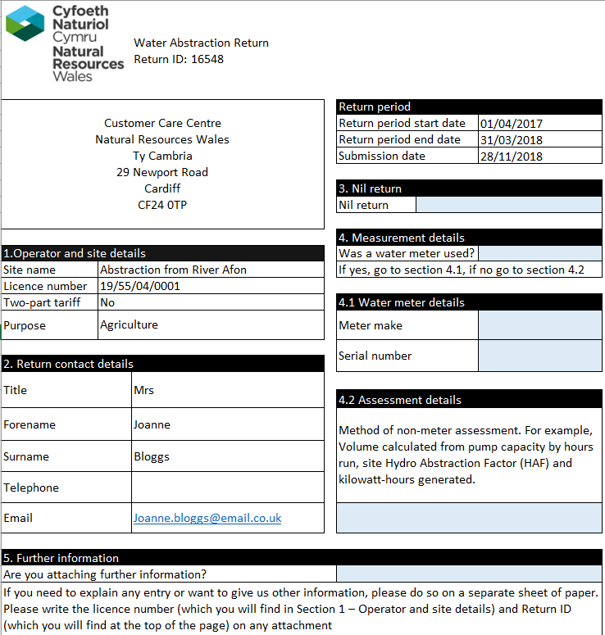
5. Further information
Enter Yes or No to indicate whether you are providing further information. If ‘Yes’, include the licence number and Return ID on any attachments
Return ID
Unique autogenerated return identification number
Return Period
Start and end dates of the period for which you should submit return information.
Boxes 1 and 2 are Operator, site and return contact details. These boxes are completed with the details we have on record for you. Please inform us if any of this information is incorrect.
4. Measurement Details
Please enter or pick yes or no from the drop down box to indicate if a water meter was used

If yes proceed to section 4.1
If no proceed to section 4.2
4.1 Water Meter details
Provide details of the water meter make and serial number. If more than one meter was used provide details in Section 5 Further information
4.2 Assessment details
If you did not use a water meter please specify the method of assessment, for example Hydro Abstraction Factor (HAF)

Completing your Daily, Weekly or Monthly return
You will either have received the standard form, detailed below or the hydro form on page 4, used by many hydropower abstractors
6. Start Meter Reading
Complete this if you if you used a meter. Enter the date and the water meter reading for first abstraction of the return period.
7a. Readings or Volumes
Please indicate whether the figures being provided are from meter readings or abstraction volumes.
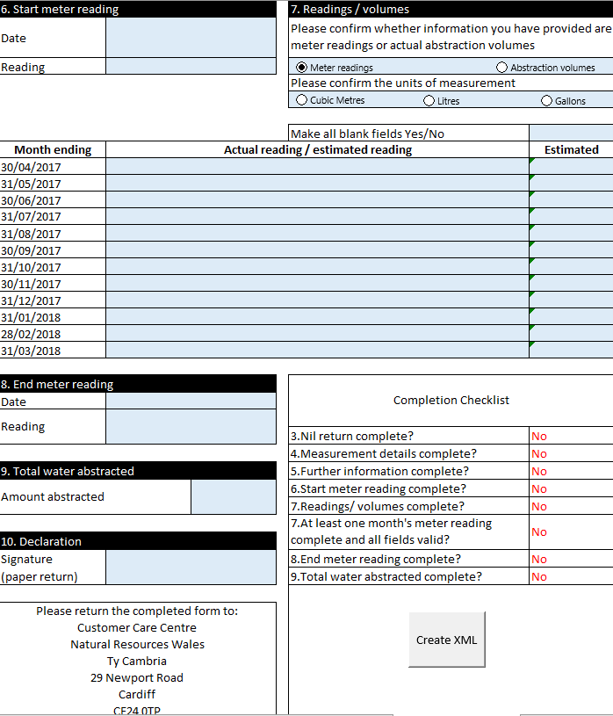
8. End Meter Reading
Complete this if you used a meter.
Enter the date and meter reading for the last abstraction during this abstraction return period.
9. Total water abstracted
Please calculate the total amount of water abstracted during the return period using the same units as selected in section 7.
If you are using Excel this box will not auto populate from data entered in Sections 6-8

10. Declaration
Paper forms only. Please sign to confirm accurate data has been provided
Please create XML file if you are using Excel, further details on page 7.

Completion Checklist
Please complete to ensure that all entries are either ‘Yes’ or ‘N/A’. This will automatically complete if you are using Excel.

7d. Please indicate whether the figures you provided are an estimate or not. This needs to be completed for each entry in the table
7c. Actual Reading/Estimated Reading
Please enter the meter reading or abstraction volume against each period in which you abstracted. To copy and paste in Excel please see page 7.
7b. Unit of measurement
Please confirm the unit of measurement for the return data provided
Enter the meter reading or abstraction volume against each relevant pre-populated date.
If you are using Excel and want to copy information from another sheet then see the ‘Copy and Paste of returns data’ guidance on page 6.

Completing Hydro Daily, Weekly or Monthly return.
Most hydro-electric abstractors will complete this form. This will use the Hydro Abstraction Factor (HAF), details of which should have been added to your licence at the time of installation.
6f. Calculated HAF
Please see detailed guidance on page 5. This will automatically calculate in electronic versions of the form.

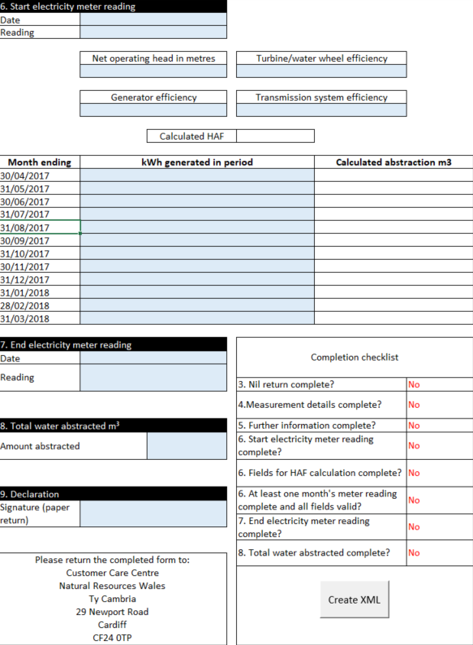
6b. Net operating head in meters
6c. Turbine/water wheel efficiency
6d. Generator Efficiency
6e. Transmission System Efficiency
Calculated HAF please see detailed guidance on page 5.
7. End electricity meter reading
You must enter the date and the electricity meter reading for the end of the abstraction return period.

8. Total water abstracted
Please calculate and provide the total amount of water generated.
9. Declaration
Paper forms only. Please sign to confirm accurate data has been provided
Completion Checklist
Please complete to ensure that all entries are either ‘Yes’ or ‘N/A’. This will automatically complete if you are using Excel.

6h Calculated Abstraction
Please calculate and provide the volume of water abstracted for each ‘kWh generated in period’ entry in column 2 of the table. This is calculated by multiplying the ‘kWh generated in period’ value by the ‘Calculated HAF’ value
This will automatically calculate in electronic versions of the form.
6g kWh generated in period
Enter the amount of electricity generated (in kilowatt hours) against each period you generated electricity.
Do not enter electricity meter readings as this will represent the cumulative amount of electricity generated.
To copy and paste in Excel please see page 7.
6a. Start electricity meter reading
Enter the date and the electricity meter reading for the start of the abstraction return period.
Please create the XML file if you are using Excel. Further details on page 6.

Completing Hydropower Daily, Weekly or Monthly return.
You will need the following information to complete the form

Net operating head in metres | Please enter the net operating head of the system at maximum power output in metres. This figure should have been obtained from your consultant/scheme designer during installation.
Turbine / water wheel efficiency | Enter the turbine / water wheel efficiency at maximum power output. This information should be available from the turbine manufacturer. Please use a value between 0 and 0.9
Generator efficiency | Please enter the generator efficiency at maximum power output. The generator efficiency should be available from the generator manufacturer. In the case of an older generator where the manufacturer no longer exists, it should be possible to estimate the efficiency based on a modern generator of the same type and specification.  Please use a value between 0 and 0.9
Transmission system efficiency | Please enter the transmission system efficiency at maximum power output. The manufacturer should be able to advise on the efficiency of the transmission system at maximum power output. Please use a value between 0 and 0.9
Calculated HAF (Hydro abstraction factor) | This box will complete automatically using the details entered above.

Please note that NRW does not hold information on site and equipment specific data. Further assistance should be sought from the company who provided the equipment or agent responsible for scheme design and construction.

Calculate the Hydro Abstraction Factor (HAF) and use this to calculate the quantities of water abstracted
To calculate the total volume abstracted for the “Calculated Abstraction m³” value in the table, you will need to use the performance data to calculate the HAF. In the Excel version of the form this is completed automatically. If you complete a form on paper you will need to complete the calculation manually using the following calculation.
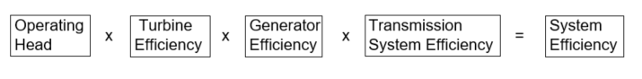
The value 366.972 is a constant derived from gravity and time and should be used in all HAF calculations.
Multiply the calculated HAF by the volume of water abstracted for any period (i.e. per day, week or month). This is the figure you should put in the “calculated abstraction m³” column.
Further details and provided in Appendix 1.

Submitting your information

Excel Forms
Once all checkboxes on the completion checklist are set to ‘Yes’ or ‘N/A’, click on the ‘Create XML’ button. This will generate the .xml file in the same location you saved the Excel file initially. Attach the files to an email and send back to us at:
waterresources.returns@naturalresourceswales.gov.uk
If you send an electronic version there is no need to print and send us a paper copy. If you encounter any issues in creating the .xml file please email us the Excel spreadsheet with details of the problem you encountered.

Paper forms
Please use the completion checklist to ensure that all required information has been provided.

When your form is complete, please send it to:
Customer Care Centre
Natural Resources Wales
Tŷ Cambria
29 Newport Road
Cardiff
CF24 0TP

You are strongly advised to retain a copy of the return for future reference, or in case there is a query with your return. Before sending your return please ensure you have enclosed any further information following the guidance provided in Section 5 of the return form.

Processing your returns
We do not send acknowledgements of receipt but will be in touch as soon as possible if there is a query with your return.

Queries
If any of your details are incorrect, or if you believe that you have received the wrong returns form, or if you have any other queries regarding your return, please contact our Customer Care Centre by telephone on 0300 065 3000 or by email at waterresources.returns@naturalresourceswales.gov.uk

Further Guidance for Excel Forms

How to open the return spreadsheet
The return spreadsheet is provided as an Excel spreadsheet attachment to the ‘return notification’ email(s) we sent you. To open the spreadsheet double-click on the attachment. Click ‘Enable Editing’, ‘Enable Content’ and/or ‘Enable Macros’ as necessary.
Click ‘Enable Editing’, ‘Enable Content’ or ‘Enable Macros’

Save the spreadsheet
Before you enter any information save the spreadsheet to your computer, to your Desktop or My Documents folder for example. Make a note of where you have saved it because the final return file created for submission to NRW will be saved in the same folder.

Copy and paste of returns data
You can copy information from another Excel sheet and paste the information into column 2 of the returns sheet (tab 2). To do this highlight the data you want to copy on your sheet and right click ‘Copy’.
Click on the returns sheet, Column 2, and right click ‘Paste Options’ then ‘Formula’ or as seen in the screen shot below (this may vary for different versions of Excel).
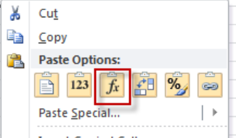

Appendix 1

Calculating the Hydro Abstraction Factor (HAF) and converting electricity generated to quantities of water abstracted

Please note: The values provided below are example values only. You must determine and use the site-specific values for your hydropower scheme. If not known, these should be sought from the company / companies who provided the equipment and / or any agent responsible for scheme design and construction.

Performance Data
Parameter | Value | How was the parameter determined?
Net operating head of the system at maximum power output (H_{n (Pmax)}) in metres | 150 | Site survey
Turbine / water wheel efficiency at maximum power output (e_{turbine/water wheel (Pmax)}) | 0.9 | From manufacturer
Generator efficiency at maximum power output (e_{generator (Pmax)}) | 0.85 | From manufacturer
Transmission system efficiency at maximum power output (e_{transmission (Pmax)}) | 0.85 | From manufacturer

Calculation of overall system efficiency of the rotating parts of the hydro system, at maximum power output (e_{system (Pmax)})

e_{system (Pmax)} = e_{turbine/water wheel (Pmax)} x e_{generator (Pmax)} x e_{transmission (Pmax)}

= 0.9 x 0.85 x 0.85

e_{system (Pmax)} = 0.65

Calculation of HAF
HAF = Hydro Abstraction Factor for the site in question

= 366.972 / ( H_{n (Pmax)} x e_{system (Pmax)} )

= 366.972 / ( 150 x 0.65 )

= 3.764 (m³ / kWh)

The volume of water abstracted for any period (V_{period}) can then be calculated by simply multiplying the HAF by the number of kilowatt hours generated thus:

V_{period} (m³) = kWh_{period} (kWh) x HAF (m³ / kWh)

If, for example, your total export of electricity for the period was 68,400 kWh, then you would have abstracted a total volume of water of:

V_{period} (m³) = 68,400kWh x 3.764m³ / kWh = 257,457.6m³

