Consultation on changes to the main river map for Wales
START DATE: 10 May 2019 – END DATE: 21 June 2019
Under the Water Act 2014, Natural Resources Wales has responsibility for maintaining and updating the main river map for Wales. A main river is defined as that included on the main river map which can be viewed here: Flood risk maps. If a watercourse is designated as a main river, it will give Natural Resources Wales the ability to exercise powers directly on it.
Through this consultation we are seeking your views on proposed changes to the main river map for Wales in Bridgend:
Morfa Brook, Bridgend
Following review of the main river map in Bridgend, a 424m section of the Morfa Brook has been identified to be de-mained. The proposed section of Morfa Brook for de-maining has had no water running down this section since the Morfa Brook was re-directed into a culverted channel during construction of the new A4061 dual carriageway. Part of the section proposed for de-maining has already been developed.
Main river changes
Type | Watercourse | Upstream Point | Downstream Point | Length (m)
Demainment | Morfa Brook | SS 91257 81441 | SS 91307 81037 | 424

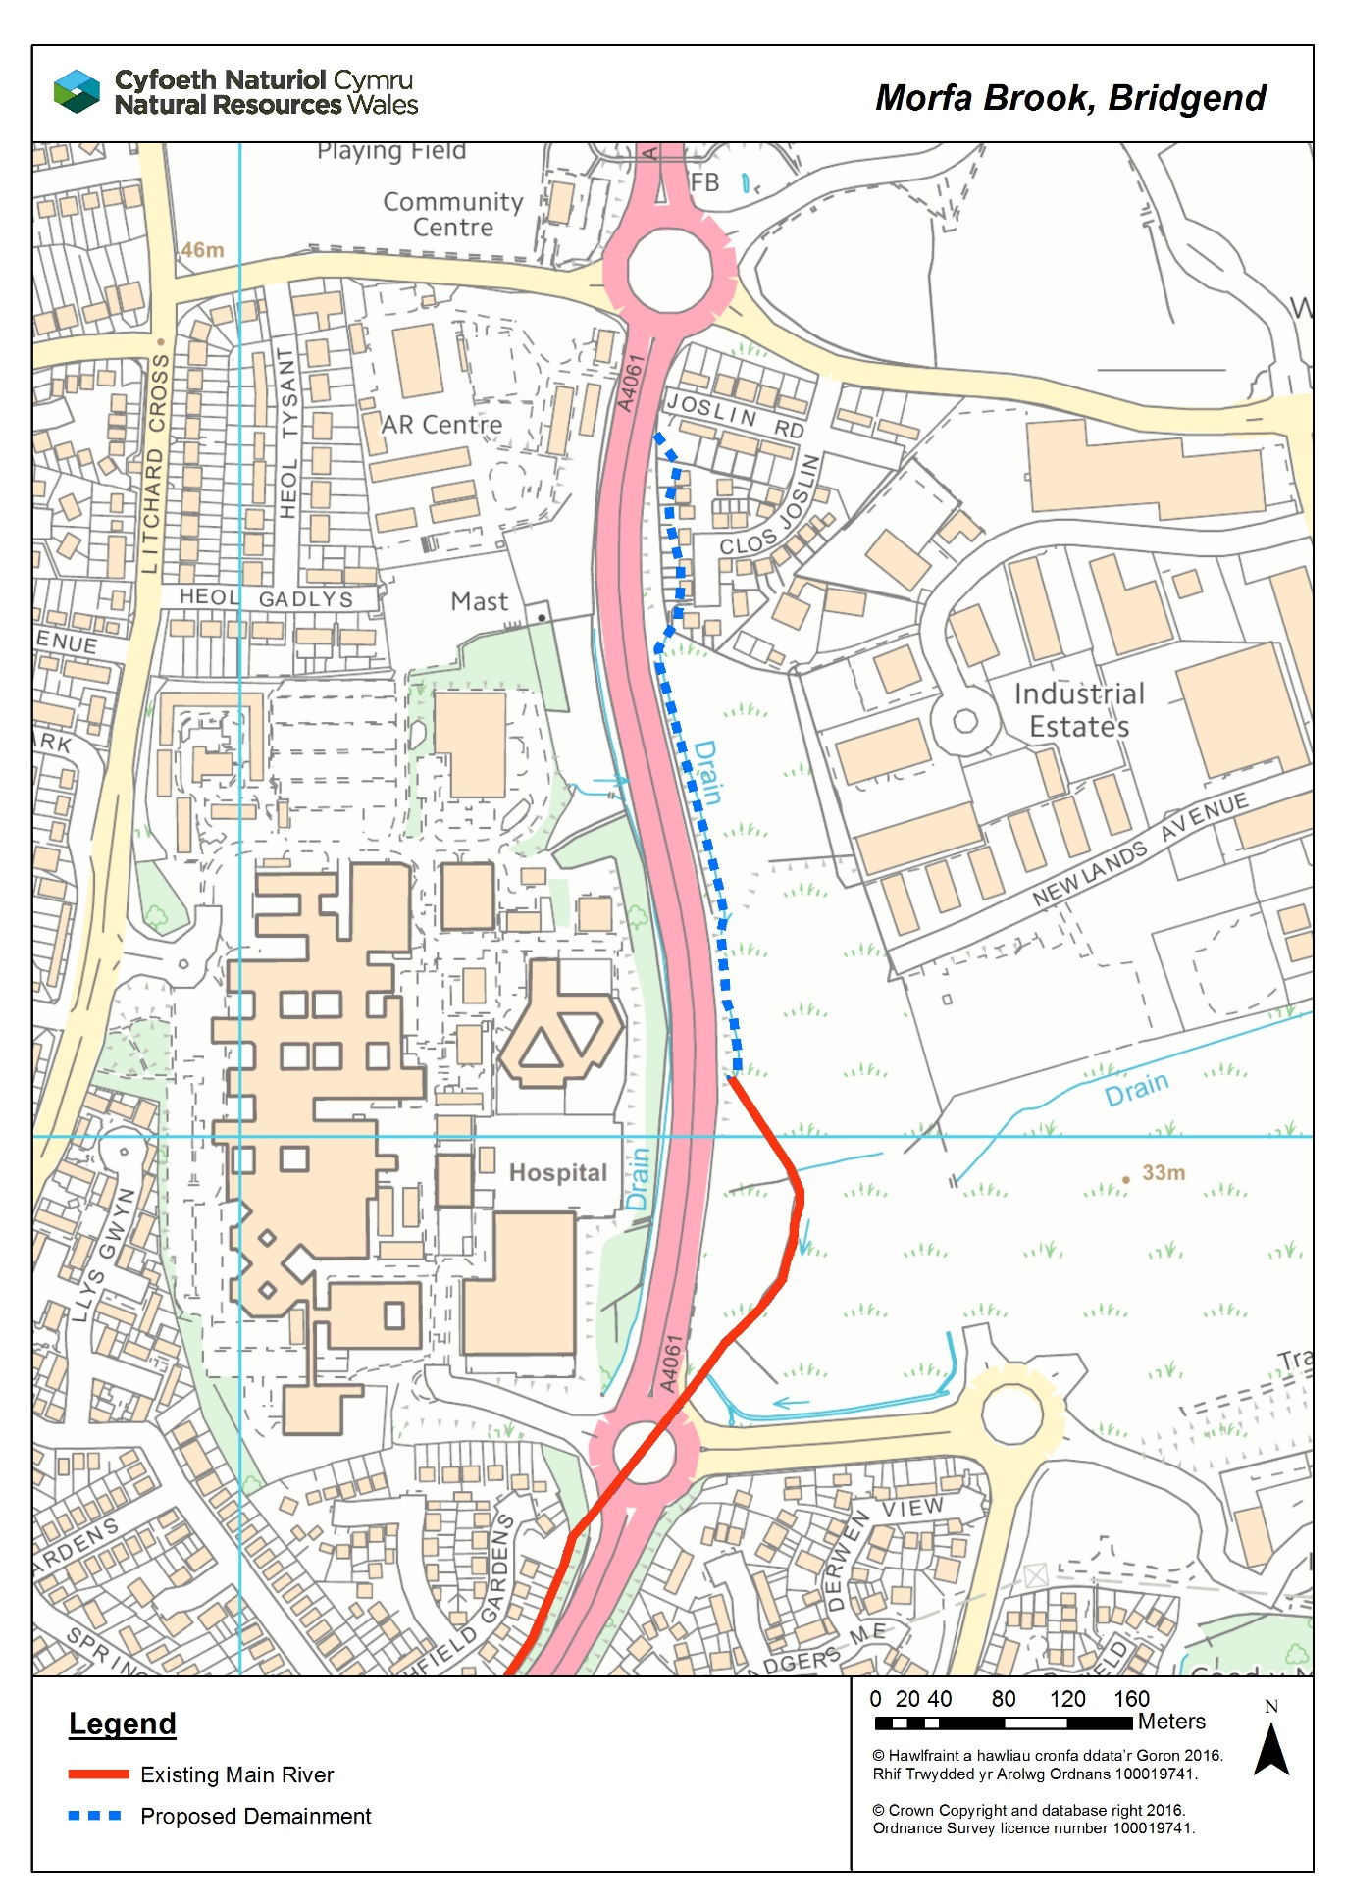

How to respond
Please submit your comments by 5pm on 21 June 2019, in any of the following ways:

Email:
main.river.enquiries@naturalresourceswales.gov.uk
or by

Post:
Main River Co-ordinator
Flood and Operational Risk Management
Natural Resources Wales
29 Newport Road
Cardiff, CF24 0TP

Publishing our consultation results
We will publish our decision following the consultation on our website by 2 August 2019.

