“It’s not revolutionary or hard. We’re just ordinary kids who have taken small steps to make our corner of the world greener”

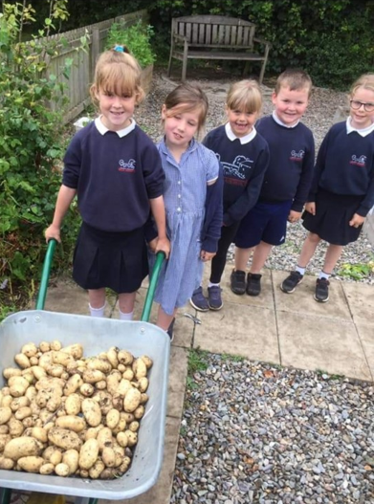
Pupils Cara Rhys Roberts and Ryan Llewelyn Davies from Ysgol Abererch, Pwllheli, winners of the S4C ‘School garden of the year competition 2021’, take a break from growing flowers, herbs and leeks to share their thoughts on school gardening.

“It all starts with a potato. Putting a potato in the soil, caring for it and lifting it from the ground. Rubbing off the soil with your hands and smelling the potato before cooking it and tasting the results of our hard work, delicious! Getting our hands dirty is really good for our immunity too” says Cara.

With several raised beds on site, support from parents and compost deliveries from a local farmer, Abererch pupils tend their garden throughout the year. Rainwater is collected from the school’s roof into water butts and seeds are harvested from plants to ensure a sustainable seed supply. Pupils’ produce is either used to learn cookery skills e.g. preparing and cooking vegetable soup or weighed and bagged into paper bags to be sold to parents.

“We’ve tried a little more each year and taken things step by step. Things don't always work, there is disappointment but that's fine, we learn from it. We've had success growing a lot of vegetables, like growing sprouts for our Christmas lunch. You've never seen so many children asking to taste sprouts! Do you have fussy children at home? I think they'll be more willing to try things they've grown themselves; I was anyway” explained Cara.

“Being out, gardening makes you respect the world around you. We are supporting biodiversity, reducing air pollution and gardening like this helps us live healthy lives. I think gardening lessons should be as essential as a maths or PE lesson” says Ryan. “Don't worry about having a lot of space or a large garden, it’s possible to grow so much in a small corner and a few buckets. Don't make excuses, go for it, and make your corner of the world a little greener.

Looking for learning resources, information or data? Please contact:
education@naturalresourceswales.gov.uk or go to https://naturalresources.wales/learning
Alternative format; large print or another language, please contact:
enquiries@naturalresourceswales.gov.uk
0300 065 3000

